Module: Accounts Payable
Topic: Vendor Maint/Reports Menu
Vendor Inquiry MUNIS Version 2019.1

Overview
The Vendor Inquiry program allows you to access the vendor file used by the Accounts Payable, Purchase Order, and Requisition programs. This program is used to report on the information contained in the Vendor file for each vendor that is set up in the system. Use this program to print vendor data or to query vendor information. Munis is very case sensitive so be sure to use CAPS once in the program.

Procedure
- Departmental Functions > Vendor Inquiry
- On the MUNIS toolbar, click Search .

Vendor Inquiry – Main Screen

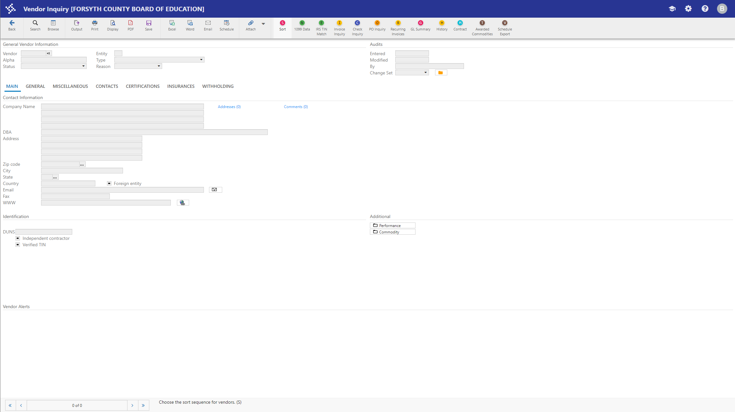

- You may search for a Vendor by full name or partial name. If you use partial name to search you must use the wildcard symbol ( * ). Once you have entered your information click
Accept . Note that there are other options that you can optionally search on listed below.

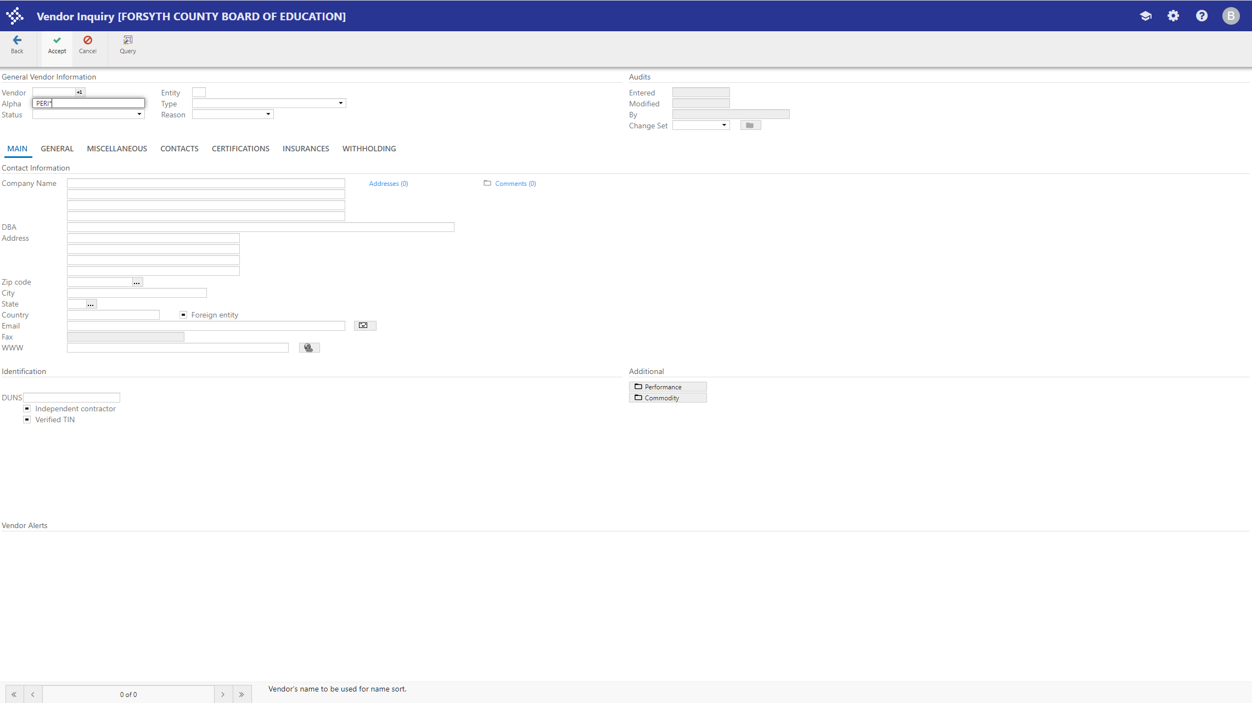

At the bottom of the screen you will see the number of Vendors that fit your criteria. If the vendor you were looking for does not appear first you may toggle between the records found by using the arrows at the bottom of the screen.

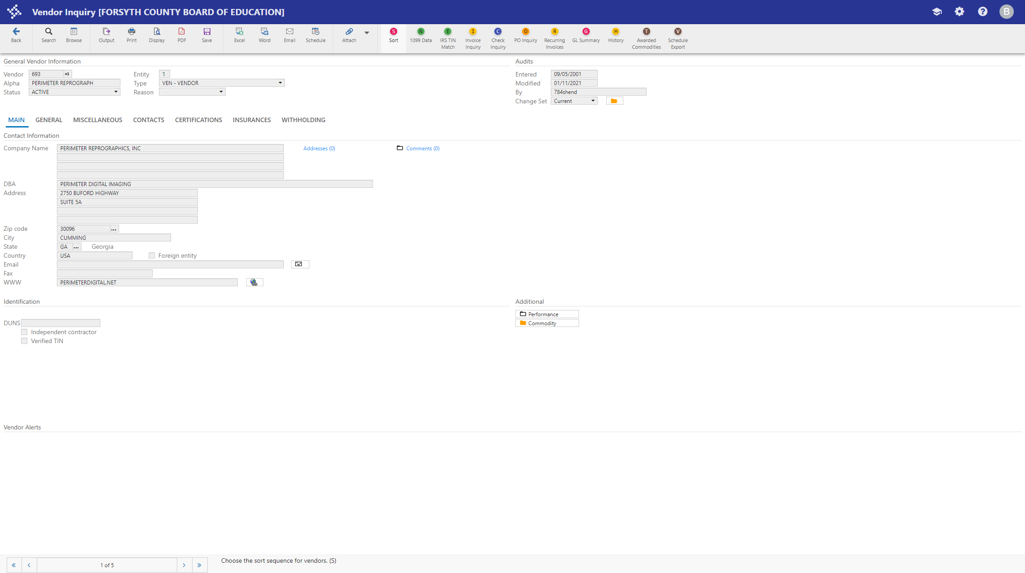
You may also click the browse icon 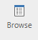 to search for the correct Vendor in a list view. Double Click on the vendor you wish to use.

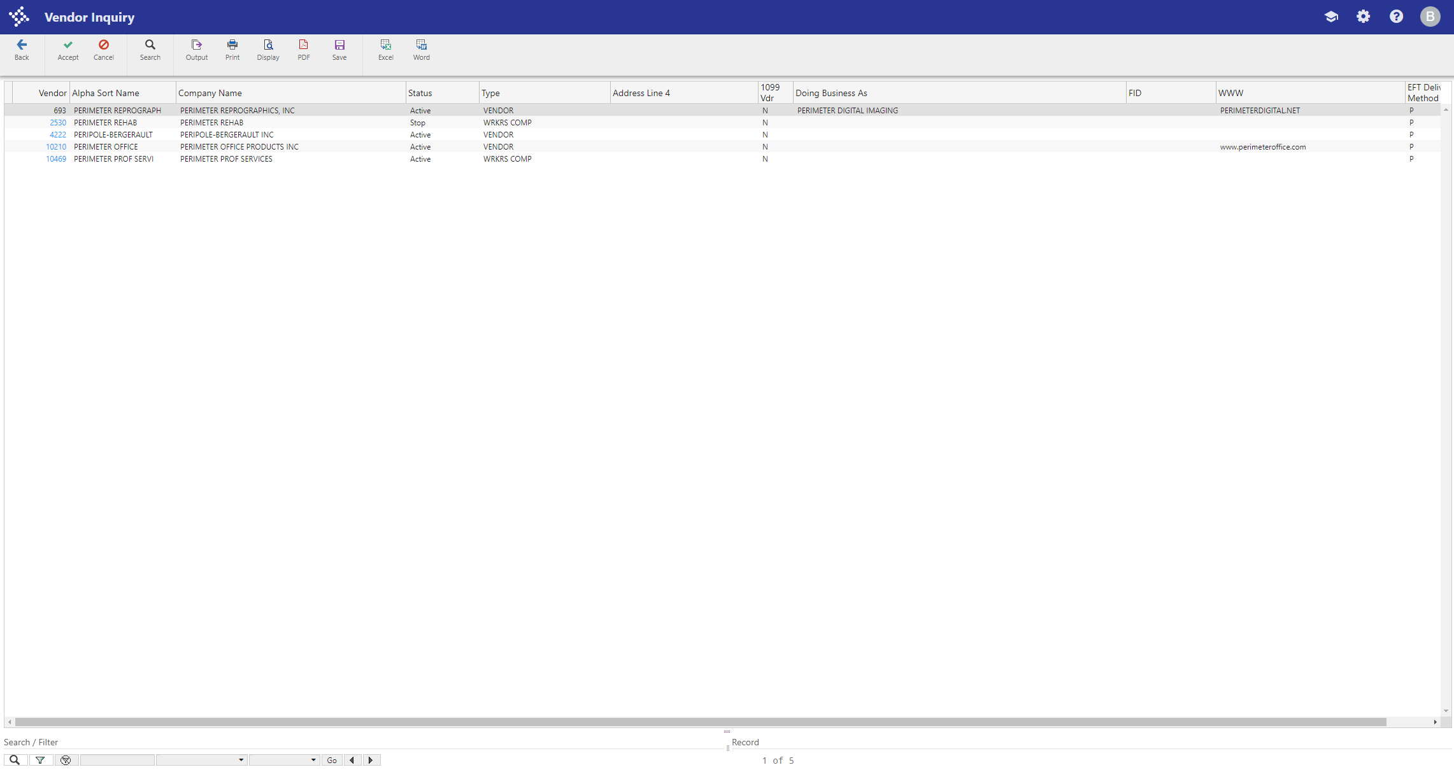

Other SEARCH Criteria that you may use:

Field | Action or Description
Vendor | This box contains the vendor number that is maintained in A/P Parameters.
Alpha | This box contains the vendor name. The name should be in the format which users would most commonly use to search. For example, if the vendor's name is The Store, it may be better to sort by Store rather than The, so you would enter "Store, The" in this field. Individual names should be in the last name, first name format. If you are searching for a vendor, type the name exactly as it was entered or use wildcard characters to narrow your search criteria.
Status | This list indicates the vendor's status. Valid options are:  - Active - Indicates a current and established vendor.  - Inactive - Provides a warning during invoice entry that the vendor is inactive  - One Time Pay - Indicates a vendor number used one time to pay multiple recipients.  - Stop - Does not allow use of this vendor during invoice entry.  - Temporary - Signifies that this vendor is only to be used for a short period of time and then deleted.  - Bidder - Identifies that this vendor is not yet an established vendor, but only a bidder. A bidder status does not prohibit entry of purchase orders and invoices.  - Self Service - Indicates a potential vendor has added their information using MUNIS Self Service.

